Computer Science

Store Database Project Documentation

Dhvani Pancholi

2018 / 2019

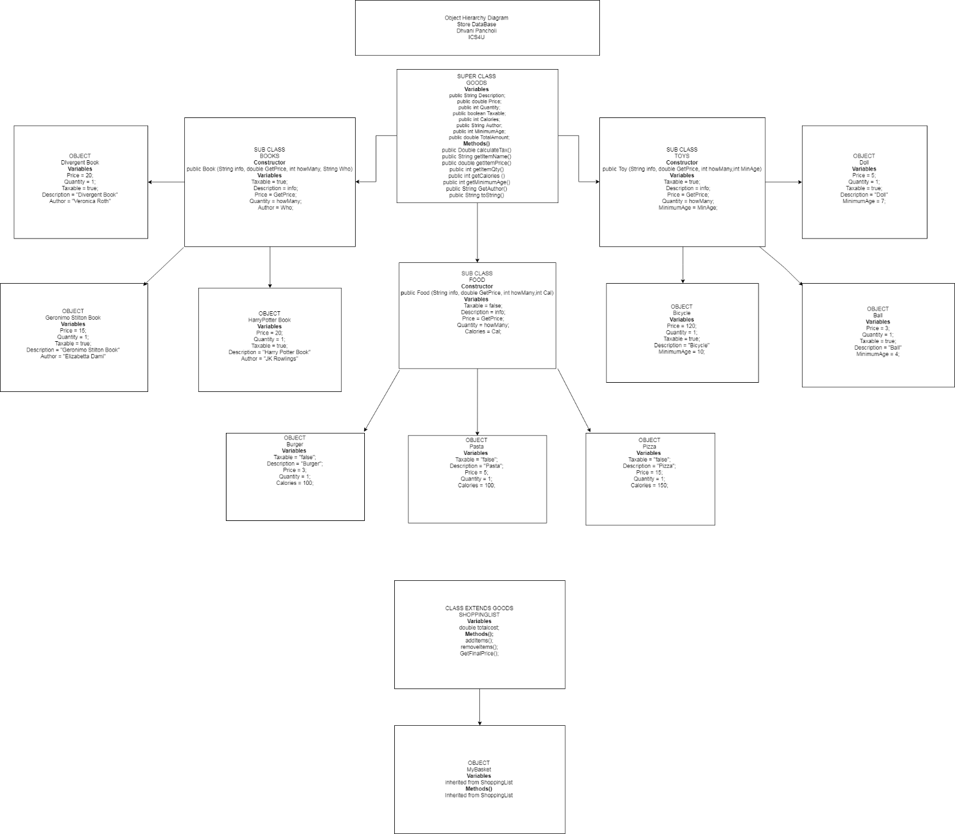OBJECT HEIRARCHY DIAGRAM

***Challenges Faced***

The store database program was an interesting assignment as it made us put all our skills learnt so far into use. My program was regularly monitored and was being updated every day and I spent a lot of hours into making this project. I feel like it really forced me to think about how I was going to design it and how I was going to implement everything I learned so far. I went through many challenges when making this program. Challenges regarding design, algorithm, programming and even debugging were a big problem to my program. I faced problems in my design where I didn’t know how I was going to separate all the different classes and keep a well-organized program with separate classes. I was stressed on how I was going to implement inheritance and polymorphism in my design when I was first creating a starting layout. I had a big problem when creating an algorithm to add and remove items from the shopping cart. Some challenges that took me a long time to solve was when I was programming and building the software. My shopping cart was being hashed when printed out from my Array List and it was not displaying the items. It took hours before I finally understood what was wrong and managed to fix it by overriding a method. I faced many problems when debugging my program because some parts of the program were not doing what they were supposed to and it was hard to find out which parts. Debugging by commenting out code was a lot of work but it paid off as it fixed the problems. A lot of challenges were faced and solved during this assignment.

***Software Architecture Description***

My program consists of 3 main classes which are Goods, Shopping List and Store Database (Main). My design implemented inheritance and polymorphism as I constructed Goods as a superclass and formed 3 subclasses called Toy, Food and Book which all inherited properties and methods from the superclass Goods. My Shopping List class holds the creation of all the objects for the superclass. It also has an object called My Basket which acts like the shopping cart. To make the program more efficient, I used an array list to store the user’s added items. I also used if statements and while loops to control user input and to make program output flexible. I combined methods and different if statements to get full user information which allows the program to offer services to the user, like adding or removing an item or to view info of an item. I believe I used proper inheritance and polymorphism in my program to create a decently efficient program which gets the job done.

***Current Limitations***

The program I created is not perfect and still has some weaknesses in its processing. I feel like the greatest limitation this program exposes is its gather of invalid user input. I have tried many types of debugging techniques to fix all its problems involving user input but sometimes the program may send out an error at the wrong time or it may handle user input properly which downgrades the programs efficiency. This was the greatest limitation I think this program has. I feel some of the other limitations in the program are very small and won’t make an impact to the program as much. The algorithms were basic algorithms that got the job done and so if there was more time, I could have added a bit of a complex algorithm to process the whole program in a different way which could have made it better. As mentioned before, the program is limited with user input, organizing and algorithms.

***Improvements***

Following up with the limitations stated previously, this program can definitely become a better and more efficient. First of all, user input is the biggest problem in this program. For Improvements, I would try planning out some ways of capturing user input before actually implementing it because I now realized that 1 out of 10 times, the program might not do what the user wants it to do. It is a low percent, but it still makes the program inefficient. I would do more research and find better ways to capture text and prevent errors or mistakes. Next, I would mainly work on the integral design and organization of the code. It is pretty organized right now but I feel like I could have separated it into a few more source files which allowed more of a clean looking class and more clarity when using inheritance with different classes. That would be my last priority but it is still one to concentrate on as it could make a positive difference. Last but not, I feel like my algorithm works pretty good at the moment but it’s a bit too basic and it could be better because it is messy and I feel like it may cause small problems. I mainly just used if statements and while loops to create the functionality of the entire program which is too simple and it wouldn’t be efficient in other programs. If I had more time to improve my program, I would definitely spend time to research and develop a better working algorithm which is easy to compute and easy to process. My program definitely requires many improvements but at the moment, I feel like I did a pretty good job building it because I challenged myself and built it using the knowledge I learned in the past 3 years. I spent a good 10 -12 hours on the assignment and I feel like it is worth it because it further developed my skills.

By Dhvani Pancholi

%3CmxGraphModel%3E%3root%3E%3CmxCell%20id%3D%220%22%2F%3E%3CmxCell%20id%3D%221%22%20parent%3D%220%22%2F%3E%3CmxCell%20id%3D%222%22%20value%3D%22Object%20Hierarchy%20Diagram%26lt%3Bbr%26gt%3BStore%20DataBase%26lt%3Bbr%26gt%3BDhvani%20Pancholi%26lt%3Bbr%26gt%3BICS4U%26lt%3Bbr%26gt%3B%22%20style%3D%22rounded%3D0%3BwhiteSpace%3Dwrap%3Bhtml%3D1%3B%22%20vertex%3D%221%22%20parent%3D%221%22%3E%3CmxGeometry%20x%3D%221015%22%20y%3D%22-1500%22%20width%3D%22530%22%20height%3D%22120%22%20as%3D%22geometry%22%2F%3E%3C%2FmxCell%3E%3C%2Froot%3E%3C%2FmxGraphModel%3E